Lesson 2: Misconceptions and Barriers to effective communication

  - Misconceptions of communication
Effective communication has been associated with persuasive communication. This is wrong, because the terms imply different communication objectives.
- Sharing information is the same thing as communicating. This is a misconception because the reality is that communication implies a two-way dialogue. This reality ties in closely with listening. Spreading information is a one-sided effort that delivers what you want to say to an audience. Communication is a two-sided relationship where both you and your audience learn from each other. This dialogue provides actionable steps to keep your communication strategy up to date and creates a deeper, more meaningful connection with your following.

- A message shared once and delivered through one medium will achieve desired results. This is not true because the reality is we communicate often and through numerous outlets to optimize a message. It takes time, thought and manpower to craft a message. This implies that in deliver there should be no cutting of corners on your delivery method. Think about the best platform, or platforms, for the communication piece and take stock of where your audience is active.

- It is possible to be an effective communicator without having good listening skills. This is false and a misconception because constantly absorb information and listen – to your audience (students). Paying attention to what is being said and thought in these areas better informs your communication needs, focus and delivery method which will help you to reach your targeted audience.

- Communication is a verbal process. This is also not true because communication is both verbal and non-verbal.

- The more communication, the better. It is not the quantity of communication, but the quality of communication that matters.
- Communication is a natural ability. This is not true. Communication may be a natural ability for some, but for most people, it is a learned ability that should be practiced. We acquire our communication skills through our education as well as our experiences. Communication competence can be learned. Practicing can and will help you communicate better.

- Communication is simply the transfer of information. This is not true.
- The biggest misunderstanding is that everyone is a communication practitioner because he or she can speak well or has a knack for writing. It is the notion that training is not necessary for one to become a good communicator practitioner. We need to be trained to have the skills in communication.
- There is the misconceptions that communication is not a specialized skill and anyone can do it with enough practice. One needs a special skill and train
- Telling is communicating. Telling is only part of communication. In communication, the sender must be sensitive to other people’s views and communication skills. Telling someone something is not communicating with him/her.
- Communication is a good thing. Communication is a tool, which is neither a good nor a bad thing. The way we use communication determines if it is a good thing or bad thing. We use communication for both positive and negative purposes.
- Communication can break down. Human communication does not break down rather we communicate unsuccessfully. Communication is always being expressed even without words, hence nonverbal communication.
  - Barriers to communication
Anything that prevents the message sent by the sender to get to the receiver to provide the appropriate feedback is termed barrier to communication. Additionally, any situation that negatively affects any of the elements of communication in the encoding and decoding processes is regarded as a barrier. The following are examples of barrier to communication.
- Misconceptions people have about communication
- Environmental (Physical) barrier – nature of the environment like noise (physical noise – outside noise, psychological noise – inattentiveness, written noise – bad handwriting, visual noise – late arrival of e.g. students), poor lighting, poor ventilation, distance, distractions, time, space, inability to see and interpret non-verbal cues like gestures, posture and general body language can make communication less effective. etc.
- Language (Syntactic and Semantic) barriers – The semantic barriers relate to different understanding and interpretation of the words we use to communicate. Syntactic barriers deals with the rules of the language. Examples of semantic and syntactic barriers include language use, errors, mispronunciation, choice of words, use of jargons, over-complicated language, use of unfamiliar and/or technical terms.
- Organizational barriers – Message from the organization (school, class) are at times given too much interpretation.
- Personal barriers – Involve components of an individual’s communication competence and interpersonal dynamics between people communicating - disability, lack of interest, discomfort with topic, some people may find it difficult to express their emotions and some topics may be completely 'off-limits' or taboo, physical disabilities.
- Psychological barriers – message from external stakeholder ignored due to “groupthink”.
- Cultural barriers - The norms of social interaction vary greatly in different cultures, as do the way in which emotions are expressed. For example, the concept of personal space varies between cultures and between different social settings.
- Attitude barriers – Expectations and prejudices, which may lead to false assumptions or stereotyping. People often hear what they expect to hear rather than what is actually said and jump to incorrect conclusions.
- Emotional barriers – It involves the emotional state of speaker, which may influence your capacity to make yourself understood and humper your understanding of others, e. g. fear/insecurity, stress.
- Technological barriers – message not delivered due to technical failure like internet failure, failure of equipment.
- Physiological barriers – message in an internal report not received due to blindness – audience not getting what is being said.
- Gender barriers - Gender barriers to communication can incite problems in class and in the school. Societal stereotypes, assumed gender roles, and interpersonal differences can contribute to a communication gap between the sexes. Gender barriers arise because men and women have different ways of thinking and communication. The chart below shows other communication barriers
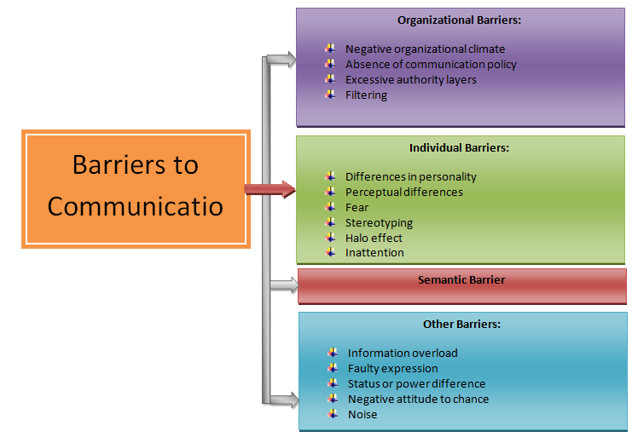
Dealing with barriers to effective communication
  - How to overcome physical Barriers
    - Have appropriate seating arrangements
    - Ensure visibility and audibility
    - Minimize visual/oral disturbances
    - Use appropriate non-verbal cues
    - Ensure proper lighting
    - Remove physical detractors
  - How to overcome attitude barriers
    - Listen to others
    - Clarify confusion
    - Stay calm and be patient
  - How to overcome emotional barriers
    - Beware of feelings
    - Communicate and attempt control them
  - How to overcome cultural barriers
    - Get help from experts
    - Work together with people in the culture more cohesively and productively
  - How to overcome language barriers
    - Learn the language
    - Use simple language
    - Use symbols and charts to explain
    - Listen actively
    - Be grammatically and sociolinguistically competent
  - How to overcome gender barriers
    - Bridge gap in gender
    - Be patient and have understanding of the genders
    - Avoid gender stereotypes
  - How to avoid technology barriers
    - Make sure network is available
    - Test material before us

Find below an illustration for how to deal with some barriers to communication
