LESSON 2

THE FLOOR OF A BUILDING
Objectives
By the end of this lesson, you must be able to:
1. describe a floor
2. write the components of a solid ground floor
3. explain some terms related to solid concrete floors
4. explain the functional requirements of a cement concrete floor
5. explain how to overcome dampness in cement concrete floors

Practice Questions
1. Briefly describe a floor
2. Write the three components of a solid ground floor
3. Explain the following terms i) Hardcore ii) Damp-proof membrane iii) Concrete bed iv) Blinding
4. Explain four functional requirements of a cement concrete floor
5. With the aid of a sketch, explain how to overcome dampness in cement concrete floors
6. Explain with four reasons, why a builder would prefer cement concrete floor to other types of floors;
7. Explain why cement concrete floor is not recommendable for a pre-school classroom.
8. The cement concrete floor of your newly built technical workshop has developed deep cracks. Briefly explain to your Principal three possible causes of this failure.

FLOORS
These are surfaces with their necessary supports which provide accommodation to the users to live at different levels in a building.
A floor is the horizontal component of a building which serves as surface for holding people, machines and furniture in the building. Floor can be constructed with concrete, clay, wood, plastics and metals. There are different types of floors such as fire resisting, hollow, industrial and solid floors.

Components of a floor: A floor is made up of these two parts
- Sub-floor
- Floor Covering

SUB-FLOOR
The lower part of a floor structure which provides support to the floor covering. It should be strong enough to support the floor covering without sinking or settlement.

Solid Floors
Solid floors can be of wood or concrete. We have, solid ground floor, suspended timber solid ground floors and suspended timber upper floors

Solid Ground Floor
It is the solid flooring directly on the earth in the building. A domestic solid ground floor consists of three main components:

1. Hardcore: A suitable filling material (ie. large aggregates of stones/granites) to make up the top soil removal and reduced level excavations. It should have a level top surface to ensure that cement grout is not lost from the concrete. It is therefore necessary to blind the top surface with a layer of sand; especially if a dampproof membrane is to be placed under the concrete bed.
Hardcore must be well compacted to prevent uneven settlement beneath the solid floor which may cause severe cracks in the concrete floor. It must also fill any small holes formed during oversight excavation.
Hardcore has the following functions;
- It provides a firm based on which to place a concrete bed.
- It helps in resisting pressure of dead and live loads on the ground floor
- It provides a strong base for the building
- It helps to reduce movement of moisture up to the ground floor.

Blinding: Blinding is used where reinforced concrete bed is specified or where a damp-proof membrane is to be placed under the concrete bed. Blinding serves as a base for the damp-proof membrane or the reinforced concrete. That is, it prevents the damp-proof membrane from being punctured by the hardcore and also provides a level surface for the reinforced concrete to be positioned. Fine ash, sand and weak concrete of 1:2 (all in) can be used as blinding. The thickness ranges between 25mm-50mm or 50mm-75mm as in the case of weak concrete.
Reinforcement (iron rods/wire mesh) is placed in cement concrete floors to strengthen it or to prevent cracks in the floor area as a result of unequal settlement or impact load (ie, commercial buildings, industrial flooring)

2. Damp-proof Membrane † an impervious layer such as heavy-duty polythene sheeting to prevent moisture passing through the floor to the interior of the building.

3. Concrete Bed † the component providing the solid level surface to which screeds and finishes can be applied.
Typical Details ~

Bed is a concrete slab resting on and supported by the subsoil, usually forming the ground floor surface. Beds (sometimes called oversite concrete) are usually cast on a layer of hardcore which is used to make up the reduced level excavation and thus raise the level of the concrete bed to a position above ground level.

Ground Floor
The floor just above the ground is called ground floor, whilst the floor constructed below ground level of a building is known as Basement Floor.
Any floor above the level of the ground floor, except the terrace or roof of a building, is termed as
Suspended floor.

Upper or Suspended Floor
Suspended floors are named in ascending order such as first floor, second floor and so on.
The name of a building in respect of its storey is governed by the number of floors it possesses. E.g a building with only one ground floor is called a one-storey building; that with ground floor and first floor as two-storey and that with ground floor and second floor is known as three-storey and so on.

FLOOR COVERING: The upper portion of a floor structure is the floor covering. The purpose of the floor covering is to have a clean, smooth, non-absorbent and durable surface. It should also be non-slippery, noiseless and pleasing in appearance.

The floor constructed at plinth level is called ground floor. These floors are constructed to provide a clean, smooth, non-absorbent and durable surface.

Functional Requirements of a Good Floor
Each type of floor has its own merits and there is not even a single type which can be suitably provided under all circumstances, and more so when floors have to serve different purposes in different types of buildings. Therefore, before final selection of any type of flooring, one must know the functional requirements that must exist in any floor system.
Keeping in view of its importance, we will talk about the requirements and functions which must be there in a good floor system.

1. Initial Cost.
The cost of construction is very important in the selection of type of floor. A floor covering of marble, granite, special clay tiles, etc. is considered to be very expensive, whereas a flooring of cork, slate, vinyl tile, etc. is moderately expensive. The floors made of concrete and brick offer the cheapest type of floor construction. It should be ensured during the comparison of cost for different floors that the cost of both the covering and sub-floor has been accounted for.

2. Appearance
Flooring should produce the desired color effect and architectural beauty in conformity with its use in the building. Generally, flooring of terrazzo, tiles, marble and cement mortar provides a good appearance whereas the asphalt covering gives an ugly appearance.

3. Cleanliness
A floor should be non-absorbent and capable of being easily and effectively cleaned. All joints in flooring should be such as to offer a watertight surface. Moreover, greasy and oily substances should neither spoil the appearance nor have a destroying effect on the flooring materials.

4. Durability
The flooring material should offer sufficient resistance to wear and tear, temperature, chemical action, etc. so as to provide long life to the floors. From the durability point of view, flooring of marble, terrazzo, tiles and concrete is considered to be of the best type. Flooring of other materials such as linoleum, rubber, cork, bricks, wood blocks, etc. can be used where heavy floor traffic is not anticipated.

5. Thermal Insulation
It should be possible for a building to maintain constant temperature or heat the inside the building irrespective of the temperature changes outside. Thermal insulation is needed to reduce the demand of heating in winter and refrigeration in summer. It is important in the case of wooden floors where heat losses are considerable and in solid floors with heating pipes or cables where the heat looses at the edges of the floor slab can be higher. Floors of wood, cork, etc. are best suited for this purpose.

6. Sound Insulation

According to modern building concepts, a floor should neither create noise when used nor transmit noise. Sometimes, it is required that any movement on the top floors should not disturb the persons working on the other floors. Suitable flooring is provided which is somewhat noiseless when traveled over.

7. Damp-resistance
All the floors, especially ground floors, should offer sufficient resistance against the dampness in buildings to ensure a healthy environment. Normally, floors of clay tiles, terrazzo, concrete bricks, etc. are preferred for use where the floors are subjected to dampness. However, on a clay base, an appreciable amount of moisture will penetrate from the ground to the floor because water table is near to the surface. The latter can be tackled by concrete slab plus water-tight membrane which can be place under, on, or in the slab.

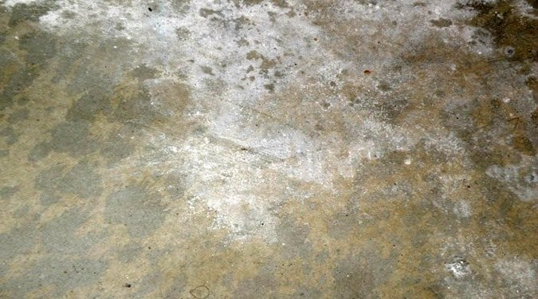

A picture of a floor showing patches of moisture effects

8. Fire Resistance of Floors
Floors should withstand fire for enough period during which the occupant can get out of the building. A good fire resistance floor begins from an hour to 4 hours which is based on the types of aggregate and the thickness of concrete cover. Reinforced concrete floors combat fire for longer period compare with timber floors.

9. Smoothness:
The floor covering should be of superior type as to exhibit a smooth and even surface. However, at the same times, it should not be too slippery which will otherwise endanger safe movements over it, particularly by old people and children.

10. Hardness:
It is desirable to use good quality floor covering, which do not give rise to any form of indentation marks, imprints, etc. when used for either supporting the loads or moving the loads over them. Normally, the hard surfaces rendered by concrete, marble, stone, etc. do not show any impressions, whereas the coverings like asphalt, cork, plastics, etc. do form marks on the surfaces when use in traffic.

Cement Concrete Floor:
The floor having its topping consisting of cement concrete is called Cement Concrete.

Types of Cement Concrete Floor:
According to the method of finishing it is classified as two types.
- Non-monolithic or bonded floor finish concrete floor.
- Monolithic floor finish concrete floor

Non-monolithic or bonded floor finish concrete floor: It is a flooring where topping is not laid monolithically with the base concrete.
METHOD:
- The earth is consolidated and 10cm thick layer of clean sand is spread.
- 10cm thick Lime Concrete (1:4:8) or Lean Cement Concrete (1:8:16) is laid thus forming base concrete.
- The topping {4cm thick Cement Concrete (1:2:4)} is laid on the third day of laying base cement concrete, thus forming Non-monolithic construction.

Monolithic Floor Finish Concrete Floor: The Cement Concrete Floor consisting of 2cm thick Cement Concrete (1:2:4) is laid monolithically with the Base Concrete.
(Monolithic means that they want the item poured/ placed at one time. This is done to prevent cold joints (due to strength reasons) or crack lines in the concrete).

Method:
- The surface of earth filling is levelled, well-watered and rammed, 10cm layer of clean and dry sand is spread over.
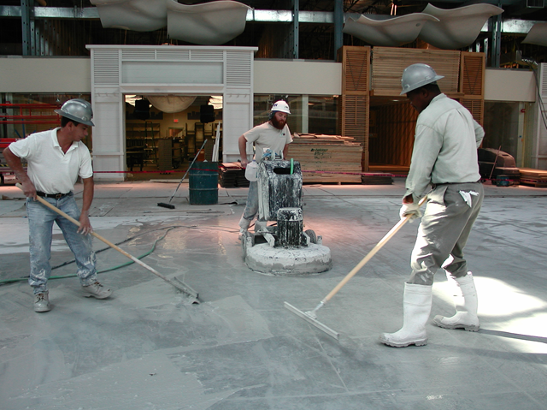
- When the sub soil conditions are not favourable, then 5cm to 10cm thick hard core of dry brick or rubble filling is laid. The topping {2cm thick layer of Cement Concrete (1:2:4)} is laid after 45 minutes to 4 hours of laying Base Concrete
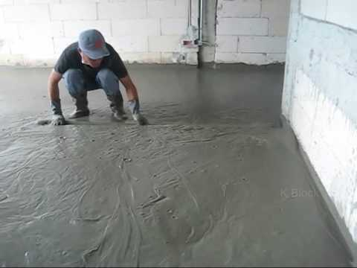

ADVANTAGES CEMENT CONCRETE FLOOR
- This floor is generally adopted in most of the commercial buildings, since it is more durable and has resistance to wearing (hard).
- It is capable of sustaining Impact loads (heavy loads), hence it is also adopted in Industrial flooring (ie: workshops/ machine shops, warehouses etc.)
- They are more fire resistance
- It acts as a base layer for other types of flooring.
- They are economical as they involve less maintenance cost
- They provide a smooth and non-absorbent surface
- They provide a more sanitary surface as they can be cleaned and washed easily

DISADVANTAGES CEMENT CONCRETE FLOOR
- These floors are not recommended for areas which will be frequently used by children and elderly people since the surface is hard and rough the risk of hurt is high if fallen.
- Due to it hardness, it makes people uncomfortable to stand on it for long periods of time.
- During cold weather the surface of the floor becomes cold since it does not tend to retain heat very well causing the nerves numb in bare foot.

