**MENSURATION**

**Volume of a Cylinder and Cone**

**Learning Outcomes:** The student teacher is expected at the end of the instruction to be able to:

1. Demonstrate the development and understanding of the concept of volume in the basic school Mathematics curriculum.
2. Use manipulatives and other TLMs to deduce the formula for finding the volume of cylinder and cone.
3. Solve everyday problems involving volume of cone and cylinder using ICT tools.

**Learning Indicators:**

1. Define the term “volume” in their own words.
2. Develop models of cone and cylinder and establish the relationship between the volume of a cylinder and cone of the same base radius and height.
3. Discus problem solving strategies in solving everyday problems involving the volume of a cylinder and cone using ICT tools.

**Ice-breakers:** How many possible triangles can you find in the diagram below:

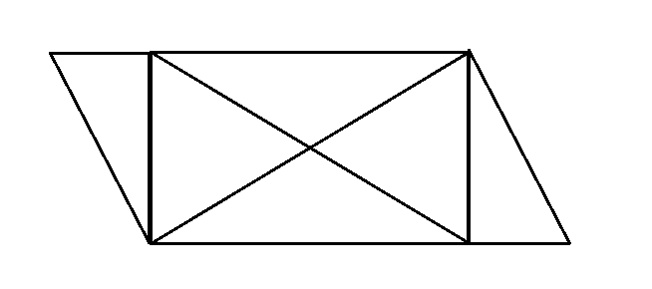

**Recap:** How do we find the volume of a cuboid?

That is by counting the number of cubes or objects that can fully occupied the space of the box.

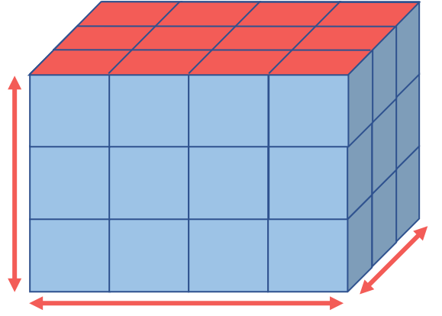

So here we have 4 cubes length, 3 cubes width and 3 cubes height. The volume hence will be cubes

Volume = Area of the base x the height

**VOLUME OF A CYLINDER**

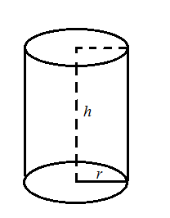Consider a cylinder with the base radius, and height. The cross sectional area of the base of the cylinder =.

Volume = Cross sectional area (circle) x height

Therefore Volume of a cylinder 



**Example 8.20**

Find the volume of a cylinder of base radius 3.5 cm and height 12 cm.

**Solution**







**Example 8.21**

A cylinder jar has a base radius 9 cm and height 14 cm. Find the volume of water it contains when

1. it is completely full
2. it is 25% full.

**Solution**

1. 





1. 25% full = 



 or 

**Example 8.22 – Try**

The volume of a cylinder is 704cm3. If the height is 3.5cm, calculate the radius.

**Solution**











**VOLUME OF A CONE**

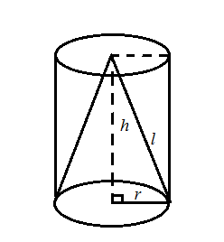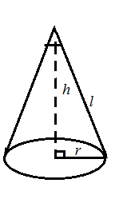

The volume of a cone has been found from experiment to be one-third the volume of a cylinder of the same base radius and height given by

Volume of a cone =  x volume of a cylinder of base radius  and height 



.

**Example 8.23**

A cone has a base radius of 7 cm and a height of 6 cm, find the volume of the cone.(Take ).

**Solution**

Volume of a cone 





**Example 8.24**

The volume of a cone with base radius 6 cm is 132 cm3. Compute the height of the cone.( Take ).

**Solution**

.









**Example 8.25**

The base radius of a cone is 5 cm and its height is 12 cm. Calculate the;

1. slant height of the cone
2. volume
3. curved surface area
4. total surface area of the cone. (Take ).

**Solution**

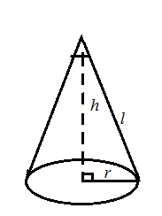

1. From the diagram, using Pythagoras theorem,









1. Volume of the cone, .





1. Curved surface area, 





1. Total surface area, 





**Assignment**

1. A cylindrical water tank has a diameter of 28cm and a height of 40cm and is filled with water to capacity. If this water is emptied into another cylinder with diameter 30cm and height is 36cm.
2. how deep will the water be in the new cylinder?
3. what volume of the new cylinder is not occupied by any water?
4. A circle has a radius of 7.5 cm. A sector with an angle of 2400 is cut out from the circle and the remaining folded to form a cone, find correct to one decimal place;
5. the radius of the cone
6. the height of the cone
7. the volume of the cone
8. the curved surface area of the cone. (Take ).
9. You are also to write a reflective journal on how you will teach the topic to a JHS 3 students in groups.

**Thank You**