LESSON: TWO

TOPIC: PROPERTIES OF TIMBER, AND DEFECTS IN TIMBER

Objectives
By the end of this lesson, students must be able to:
- understand the properties of timber
- understand the defects in timber

Practice Questions
- Explain 5 properties of timber
- Describe 5 types of defects in timber

Properties of Timber - Qualities of Good Timber & Wood (Author - Shanta Urmila Mou)

Timber is a type of wood which has been processed into beams and planks. It is also known as “lumber” in US and Canada. Basically, timber or Lumber is a wood or firewood of growing trees. Any wood capable of yielding a minimum dimensional size can be termed as a timber or lumber. It is a stage in the process of wood production. Timbers are used for the structural purpose. Those woods which are adapted for building purposes are timbers. Finished timber is supplied in standard sizes for the industry. Timber is used for building houses and making furniture.
There is high demand for timber as a building material. From building construction to furniture making, timbers have numerous uses. These uses have made timber an important building material.

Properties of Timber
The quality of timber must be ensured before using it for a purpose. The quality can be ensured by investigating the properties of timber. Here we have discussed both physical and mechanical properties of timber which affects timber quality.
Followings are the physical and mechanical properties of timber:
- Colour
- Appearance
- Hardness
- Specific Gravity
- Moisture Content
- Grain
- Shrinkage and Swelling
- Strength
- Density
- Toughness
- Elasticity
- Warping
- Durability
- Defectless
- Workability
- Soundness
- Free of abrasion
While selecting timbers for use, one must check these properties to ensure the quality. At the same time, it is also essential to ensure that the timber is defectless. To learn more about timber defects read: Defects in Timber | Defect Types & Causes
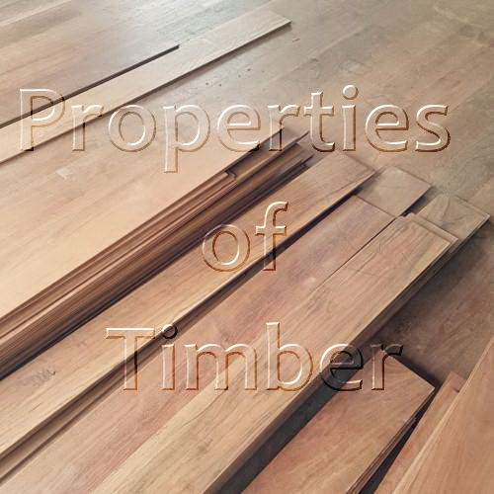

These properties are briefly discussed below:

Colour
Color is a uniform property by which most trees are characterized as they show variation from tree to tree. Light color indicates weak timber. For example, freshly cut teak, Deodar, and Walnut have a golden yellow, whitish and dark brown shades respectively.

Appearance
Smell is a good property as timbers for few plants as they can be identified by their characteristic aroma. Fresh cut timbers have a good smell. For example resinous smell from pine.

Hardness
For the resistance of any kind of damage, hardness is an obvious property.

Specific Gravity
Variation of timber in specific gravity (0.3-0.9) is found. It depends on pores present inside timber. The specific gravity of this light material is less than that of water (<1). But in case of compact wood where pores are almost absent and become heavier, their specific gravity increases up to 1.5.

Moisture Content
Timbers are hygroscopic and gain water from nature (atmosphere). The absorption of water or dehydration depends on atmospheric humidity. If timbers moisture content is high that means the timber quality is low. Water content is the risk of fungal attack.

Grain
Several types of grain arrangement found. On the grain structure quality of timber varies. Grains remain closely related.
- Straight grain: Arrangement of vascular tissue (xylem and phloem) is important which grow parallel to the length of the timber that is termed as straight grain.
- Coarse grain: vascular tissue and fibre arranged broadly and widely.
- Interlocked grain: Instead of parallel arrangement twisted, a spiral arrangement may be found.

Shrinkage and Swelling
The percentage of shrinkage and swelling varies from plant to plant. Some give higher percentage after drying. Shrinkage starts when cell walls of timber start to release water. In moisture atmosphere timber swells when cell walls absorb water. Good quality timbers swell less. Timbers having thicker wall swell more than a thinner one.

Strength
Best quality timbers have the highest strength. Strength means capable to bear loads. Anisotropic material like timber has different structure at the different portion. So, the strength of timber is different at different points. Grain structure determines the strength of the timber. Some types of strength are
- Compressive strength: 500 kg/cm2 to 700 kg/cm2 load is enough to test timbers strength.
- Tensile strength: When timber is enough strong to the tensile force. If perpendicular force is made then timber is weaker. 500-2000 kg/cm2 is the range of tensile strength load.
- Transverse strength: Enough bending strength indicates good quality timber.

Density
Timber having higher density have a thicker wall. An important property that quality of timber. Moisture content: Presence of defects: There may be some of the natural and artificial defects in timber such as cross-grain, knots, and shakes, etc. All of them cause a decrease in the strength of the timber.

Toughness
Timber has to have the capability to bear shocks, jerk. Anti-bending and ant splitting characteristic is needed. Old timbers have annual rings which indicate their age is a good indicator.

Elasticity
Another property elasticity means timber should attain its own shape after use. Because of this quality, it is used in sports bat.

Warping
Environmental change with season can’t effect good quality timber.

Durability
A good quality timber has the property to resist the attack the infection of fungus or other insects. This resistance quality makes timber better.

Defectless
This property is gained if the timber is from a sound tree. A defectless tree is free from sap, shakes, and dead knots. To know more about timber defects read: Defects in Timber

Workability
A good timber is always easy to work on it. Easy to drag using saw on good timber. The finishing can be done well.

Soundness
A good quality timber gives good sound.
Texture
The texture of good timber is fine and even.

Free of Abrasion
Timber should not be damaged by the external environment. It has to gain the ability to protect its skin

Defects in Timber | Defect Types & Causes (Author- Faisal Ahmed)
Timber is a natural product and every natural product has some imperfections. Timbers are not excluded from that. Most of the defects in timber cause weakness or others sorts of difficulties. However some defects can be beneficial for a specific type of work, for example, twisted wood is good for making a bowl out of timber.

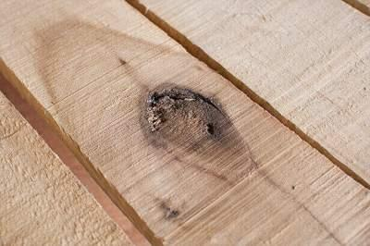

A defect in Timber Example Image Source: diy.sndimg.com

The followings are the five main types of defects in timber:
- Defects due to Natural Forces
- Defects due to Attack by Insects
- Defects due to Fungi
- Defects due to Defective Seasoning
- Defects due to Defective Conversion

These timber defects are briefly discussed below:

Defects in Timber due to Natural Forces
- Knots: Knots are the most common defects caused due to natural forces. During the growth of a tree, branches close to the ground or lower branches die. Bases of those branches remain in the tree as the trees grow. These bases may create imperfection known as knots.
Types of Knots: Knots are of two types.
  - Dead knots: The remains of damaged branches after drying out they become loose and fall out.
  - Live knots: They are sound and firm. If small, are not great of a defect.
Live knots are usually not a problem as they remain firmly attached to the timber. But in dead knots, they are loosely attached and reduce strength. Knots decrease the strength of the wood and thus lower its value for structural uses. Knots cause serious defects when the load is perpendicular to the grains.
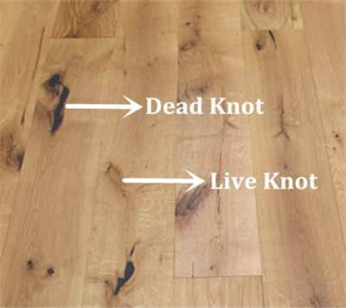
Dead knot and Live Knot. Source: woodexportchile.com

- Twist: Twist in timber rotates the ends of the timber in opposite directions. The main reason behind this defect is twisting of the trees by the strong wind.
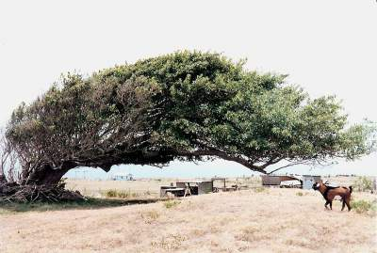
Twisting of the trees by the strong wind. Source: commons. wikimedia.org

- Shakes: Shakes are timber defects that occur around the annual ring or growth ring of a timber. In other words, cracks or splits in the woods are called shakes.
It may or may not be a structural problem depending upon depth and use. The main problem is aesthetic. Where the appearance is important, shakes are undesirable.
Types of shakes: Shakes can be classified into three main categories:-
  - Star Shakes: This type of shake starts propagating from the bark towards the sapwood and sometimes even towards the heartwood along the lines of medullary rays. Cracks are wider on the outer edge or bark and narrower on the inside (usually sapwood, sometimes heartwood). The main reasons behind star shakes are extreme heat or frosting during the growth of the trees and rapid or uneven seasoning after cutting off the timber. Extreme heat or frost causes temperature difference, which causes shrinkage leading to the crack.

  - Cup and/or Ring Shakes: Cup shakes follow the annual growth ring. It is capable to separate the growth ring partially or completely. When the crack separates the annual ring completely, it is called ring shakes. So, all ring shakes are cup shakes, but all cup shakes are not a ring shape. Excessive frost action is the main reason for this type of crack.
  - Heart Shakes: Unlike star shakes, heart shakes start propagating from the pith to the sapwood along the lines of medullary rays. Shrinkage of the interior part of the timber causes this crack.
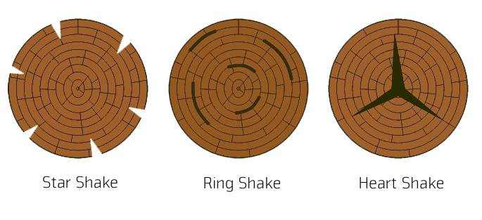

- Rind Galls: The meaning of rind is bark and gall is abnormal growth. So abnormal growth of the bark of the trees is called rind galls. Improper cutting of branches causes this abnormal growth. Wood from this portion of the timber lacks strength and desirable in structure.

- Upsets: Upsets in various wood indicate that the tree was subjected to crushing or compression. Improper felling of trees, heavy wind blowing during the young age of the tree these are the main reasons behind this type of defect.

Defects of Timber due to Attack by Insects
Insects like beetles, termites or marine boars eat wood, make holes and weaken the strength of the wood.
Beetles are small insects that make holes in almost all the sapwoods. The larvae make tunnels through the sapwood in all directions and turn wood into powder.
Termites live in a colony. They are very fast in eating woods and making tunnels through it. Only a few good kinds of wood can withstand the action of termites.
Marine boars are found in salt water. Usually, they make tunnels in wood to take refuge or shelter. All kinds of wood or timber are vulnerable to this kind of insect.

Defects in Timber due to Attack by Fungi
- Stain: When fungi feed only on sapwood, where the food materials are stored, it causes a stain. Heartwood doesn’t contain these kinds of food materials and is not affected by it. Stain action causes color but does not affect the strength of the wood.

- Decay: wood eating or wood destroying fungus is responsible for this type of defect in wood. This type of fungi breaks down the cell structure. Both sapwood and heartwood are affected by them. Considerable strength reduction occurs.

Defect in Timber due to Defective Seasoning
Faulty method of seasoning causes serious defects in woods. During seasoning of timber, exterior or surface layer of the timber dries before the interior surface. So, stress is developed due to the difference in shrinkage. In a perfect seasoning process, stress is kept minimum by controlling the shrinkage. Some of the defects resulting from defective seasoning are as follows:-
- Bow: Curvature formed in direction of the length of the timber is called bow.
- Cup: Curvature formed in the transverse direction of the timber is called a cup.
- Check: Check is a kind of crack that separates fibers, but it doesn’t extend from one end to another.
- Split: Split is a special type of check that extends from one end to another.
- Honey Combing: Stress is developed in the heartwood during the drying process or seasoning. For these stresses, cracks are created in the form of honeycomb texture.

Defects of Timber due to Defective Conversion
- Boxed Heart: This term is applied to the timber, which is sawn in a way that the pith or the center heart falls entirely within the surface throughout its length.
- Machine Burnt: Overheating is the main reason for this defect.
- Machine Notches: defective holding and pulling causes this defect.
- Miscut: erroneous cutting or sawing of wood causes this defect. Lack of experience in sawing and carelessness is the main reason for erroneous cutting.
- Imperfect Grain: Mismatch in grain alignment

Section Two - The Physical and Mechanical Properties of Wood

Introduction
This lesson covers the physical and mechanical properties of wood. Physical properties refer to density and moisture relations that affect its use. Mechanical properties refer to the strength characteristics of wood.

Physical Properties
Density
Wood is a porous material made up of cells of various kinds. Depending on the nature of these cells, some woods have more or less solid wood substance for a given sized piece. If you think of a brick of Swiss cheese (with all its holes) and an identical-size brick of cheddar, you can guess that the cheddar brick contains more cheese. So, with wood, the fewer holes (cells), the more wood substance.
The amount of wood substance for a given volume determines density. Woods with more weight for a given volume have a higher density than woods with less weight. Both weight and volume of wood are affected by the amount of moisture it contains. Therefore, when specifying density, it is important to also state moisture conditions. For example, the density of air-dried balsam fir is 430. This means it weighs 430 kg. per m3, at 12 percent moisture content - a standard for strength testing and density measurement. By comparison, the density of red spruce is 450; and sugar maple, is 740, again both in the air-dry condition.
As discussed in Lesson 1, density is an excellent indicator of wood strength; the higher the density the stronger the wood. However, a wood with a density of 600 may not be twice as strong as one with a density of 300. It depends on the strength properties being discussed. For example, the amount of deflection of wood in response to a load (modulus of elasticity), as in a joist or rafter, is an important strength property. The actual breaking strength of the piece, rupture (modulus of rupture), is also important.

Growth Rate
It has been shown how rate of growth affects the mechanical properties of wood. But how does growth rate affect density? There are no hard and fast rules applying to all species, on how growth affects density. Individual species, or groups of species, must be considered to get some idea how rate of growth affects density, and in turn, strength.
Growth rate affects the density of softwood differently for different species. In general, density values fall off more severely with very rapid growth, than with very slow growth. The optimum being something in between. The pulp and paper industry found out long ago that maximum yield of pulp was not simply an expression of volume of wood per hectare but had a lot to do with growth rate of the trees.
The effect of growth rate on density is easier to predict for hardwoods. Density of diffuse-porous species - maples, birches, and beech -do not vary with growth except perhaps for extremely slow growth. On the other hand, ring-porous species - oak and ash - show highest densities (and strength) for moderately rapid growth. Very slow growth in this group results in marked reduction of density. For hardwoods, strength is usually not a critical property.
Hardwoods are used more for their appearance and decorative features. However, for pallets, frame stock, and timbers, strength is a factor.
Proportions of Springwood & Summerwood
Timber showing the greatest proportion of latewood - with thick-walled cells - has the highest density and in turn strength. Both growth rate and percentage of latewood are used in certain grading rules for some species. When safety factors are especially important such as for scaffolding or bridge work, inspectors visually check the ends of timbers for percentage latewood.

Moisture Content
Free Water and Bound Water
Water exists in wood as either free water or bound water. Free water occurs within a cell cavity as a liquid. It is the easiest and first to be removed during drying. This free water moves toward the end surfaces through connecting cells, and laterally through the pits of neighbouring cells. It is evaporated from the wood faces as well as the ends. The point at which all free water is removed from the cell cavity is known as the fibre saturation point (fsp) and is reached at around 30 percent moisture content.
Figure 9 - Anatomy of longitudinal cells, in relation to moisture loss.
Bound water is moisture absorbed within the cell wall. This water is molecularly bound to the wood molecules of the cell. It is therefore much more difficult to remove than free water. Figure 9 shows this process. Shrinkage takes place only when bound water is removed.

Effect of Moisture Loss on Strength
The loss of free water, down to the fsp, has no effect on the strength of wood. However, when bound water begins to be removed, most strength properties increase. The increase in strength is directly related to the amount of moisture removed. Thus, other things being equal, a spruce 2 x 4 (stud) is stronger at 18 percent moisture content than one green from the saw.

Other Properties Affecting Strength
Slope of Grain
This refers to a deviation of the line of longitudinal cells, to a straight line parallel to the sides of the piece of lumber. It may be caused by an abnormal growth pattern in the tree, or how the log was sawn. It is usually expressed as a ratio; for example, 1 in 12 (finch of slope in 12-inches length). A slope of grain of 1 in 6 results in a 60 percent reduction in bending strength (strength of a horizontal beam, such as a floor joist, for example). A 1 in 16 slope causes only a 20 percent reduction (see Figure 7). Most lumber grading rules specify the maximum slope of grain permitted in the grade.
Knots
Knots, common in sawn products, are caused by limbs on the tree stem. When a saw cuts through a limb (or its stub) a knot remains. Depending on the angle of both the limb and the saw, a round knot, an oval knot, or a spike knot (longitudinal) will result. For strength purposes knots are classified by size, number, form, and quality. The first two classes are self-evident. Knot form and quality are described as: tight, loose, intergrown, firm and rotten. Most grading rules take these factors into account.
Figure 10 - Shakes and Checks
Shakes and Checks
These are separations occurring in the wood (see Figure 10). Shakes parallel to the annual rings are called ring shake and those in the heart of the tree and perpendicular to the annual rings are called star shake. In living trees, both forms of shake are caused by wounds, but not all wounds result in shake. Factors that may extend the formation of shake are, internal growth stresses, bending of the tree by wind and the freezing of free water within the cells. Checks are generally produced in the rays of sawn-wood products during drying. Depending on their severity, checks and shakes have a very great affect in reducing the strength of wood.

Agents Causing Wood Decay
Figure 11 - Tree stem showing fungi conks, indicating very advanced decay.
Decay
Decay, or rot; is not permitted in wood used for structural purposes. Recognizing decay in wood is very important. Most decay in wood is caused by fungi. Some of these mushroom like organisms (see Figure 11) attack the wood, eventually destroying its cellular structure. Fungi may originate in the growing tree or the wood may become infected after it is in use. Most fungi originating in the growing tree do not continue to degrade the wood during use.
The most serious and common type of wood decay in softwoods in Canada is known as brown rot, or brown cubical rot. It is caused by two fungi and proceeds very quickly under favourable conditions for rot. These fungi cause most of the extensive losses from decay in wooden buildings in North America. In hardwoods, the white rots are most common.
Stains, Molds, and Bacteria
Stains and molds in wood are not as serious as decay and are usually accepted in structural timber in local markets. Stain may be caused by fungi and is often an indication of worse things to come. Usually, molds and stain fungi merely give an unpleasant colour to the wood. One common example is the sap staining fungi causing blue-stain in green wood. Bacteria, another type of organism that attacks wood, and was once thought to result in little damage is now known to produce enzymes, which cause shakes in red oak. During kiln drying of red oak affected by these bacteria, honeycombing and serious checking may often develop.

Conditions Promoting Decay
To develop and cause wood damage, fungi requires food, air, moisture, and warmth. If any one of these conditions is removed, the fungi will die or remain dormant. One of the most common misconceptions and misused terms is `dry-rot'; often used to describe the brown cubical rot mentioned earlier. The dry condition may be due to the time one observes the damage - long after the rot has taken place and perhaps on a dry day. Decay will not proceed unless there is sufficient moisture available. The critical moisture content below which fungi cannot function is 20 percent.

Effect of Silviculture on Wood Properties
Good silviculture practices affect wood properties. In softwoods, good thinning and proper spacing can enhance growth rates, strength, and other properties. Moreover, spacing can be tailored to the targeted product. For pulpwood species, proper spacing can produce high quality fibre and yield which may not be the same as high volume. For trees destined for structural lumber, spacing can be done to produce a growth rate giving optimum strength. For yard lumber (general construction lumber) - where volume is the main goal - other spacing prescriptions apply.
In hardwoods, quality is more important than volume. Remember, fairly high growth rates in diffuse-porous woods are desirable. For ring-porous species, extremely high growth rates are not desirable. Nor are extremely slow growth rates. Where strength is a factor six rings per inch is a minimum.
For decorative uses, somewhat slower growth rates are preferred to produce a finer texture. Stands can be tended to provide the required qualities. For example, a sudden and severe opening up of the stand may cause the formation of branches in many trees. These become knots, in lumber or veneer. Selection harvesting and shelterwoods can be designed to remove old, decay-ridden trees. This practice will decrease the chances of infection occurring in the younger trees in the stand. More will be said on silviculture and harvesting methods in the next lesson.

Wood Properties for Selected Products

Pulp & Paper
- Newsprint - mechanical and groundwood pulps. Most softwood species are acceptable, but those with considerable latewood are not favoured (eg. larch, pine). Length of longitudinal cells; ie. fibres, is important. Spruces, particularly black spruce, produce the highest quality newsprint largely due to cell length. Thermo-mechanical pulp (TMP), now mainly used in newsprint installations, requires the same properties.
- Chemical Pulps - Sulphite and Kraft. Sulphite pulp is usually mixed with groundwood pulp for newsprint. Kraft pulp is used in many applications, particularly for linerboard. Almost any species and quality of wood may be used for kraft. For sulphite, woods with very heavy latewood are not usable. Both produce strong pulps, and strength is related to longitudinal cell length. Black spruce best demonstrates these qualities.

Lumber
- Softwood - Softwoods are used primarily for structural and construction lumber, but also find their way into products such as trusses and laminated timbers. These must contain pieces that have properties favouring high strength, such as: moderate growth rate; high proportion of summerwood; straight grain, no compression wood; low moisture content; no decay. For less demanding uses, including construction lumber, most of these properties are not as important.
- Hardwood - Since hardwood is used extensively in decorative applications such as mouldings, furniture and cabinets, its appearance is most important. Properties that enhance appearance and performance include: moderate growth rate; well-defined annual rings, rays and pores to produce a pleasing `grain'; absence of shakes or checks in finished product; all heartwood or all sapwood to feature colour integrity; very exact moisture content with little or no variation within or between pieces so that shrinkage does not take place in use.

Handles and Turnery
Pieces should be strong, straight-grained, with a moderate growth rate, no tension wood, no knots, shakes, checks, or decay, high proportion of late wood.

Panel Products
There is a range of panel products. One type is made from veneer logs, other types from low-density woods, and others from mill residue. Plywood is made from veneer, oriented strand board (OSB) from aligned wafers, particle board from small particles, and fibreboard from fibres and fibre bundles.
OSB wafers are sliced from small roundwood, usually poplar. Particleboard and fibreboard are produced from a mixture of chipped roundwood (softwood and poplar) and softwood sawmill residues (sawdust and planer shavings).
Softwood plywood and OSB can be used for structural purposes. Hardwood plywood is used in furniture and cabinet making. Particleboard and fibreboard are also often used in finished products such as furniture.
Other Products
There are many other wood products. Some of them have specialized properties. Recently developed products include laminated veneer lumber (LVL), finger jointed lumber and edged glued panels. These are generally made from lower grade material (with corresponding lower level properties) to make a highly usable, high strength product.

Selected Strength Values
Mechanical properties of wood is extracted from Canadian Woods (1). The following brief comments refer to it:
- Regard the values as relative to each other to get a good impression of strength.
- Rupture is a measure of the ultimate strength of wood at the breaking point.
- Elasticity is deflection in response to load. Even though a piece of wood will not break under a load (weight) it may deflect to such an extent that it cannot be used. This applies to such applications as floor joists, rafters, etc.

Further Reading
- Mullins, E.J. and T.S. McKnight, 1981.
Canadian Woods - Their Properties and Uses Third Edition, Supply and Services Canada, Ottawa.
- Jessome, A.P., 1977. Strength and Related Properties of Woods grown in Canada, Forintek Canada Corp., Ottawa
- Bodig, Joseph and Benjamin Jayne, 1982. Mechanics of Wood and Wood Composites, Van Nostrand Reinhold, Toronto
- Cech, M.Y. and F. Pfaff, 1977. Kiln Operator's Manual For Eastern Canada, Forintek Canada Corp., Ottawa
- Calvert, WW. and F.J. Petro, 1993. Grading_Standing Hardwood Trees in Nova Scotia, N. S. Dept Natural Resources, Halifax

