LESSON: THREE

TOPIC: WOODEN DOORS, WINDOWS, AND FRAMES

Objectives
By the end of this lesson, students must be able to:
- identify parts of wooden doors and windows.
- describe the types of wooden doors and windows.
- identify types of windows and door frames
- identify types of joints suitable for construction of windows and door frames
- describe types of timber suitable for wooden doors and windows
- explain the advantages and disadvantages of wooden doors and windows
- outline the precautions while installing wooden doors and windows

Practice Questions
- Sketch and identify parts of wooden doors and windows.
- describe 3 types of wooden doors and windows.
- Identify 3 types of window and door frames
- describe 3 types of joints suitable for doors and window frames
- describe 3 types of timber suitable for wooden doors and windows
- explain 4 advantages and 3 disadvantages of wooden doors and windows
- outline 5 precautions to be observed while installing wooden doors and windows

PARTS OF A DOOR EXPLAINED

Doors form a vital part of the make-up of any property. Most homes and buildings will feature multiple entrances and internal doorways, using a range of different doors that are carrying out a variety of functions.
While they have an important practical function to fulfil, the design and style of doors can influence the overall character of a property - and the design options are endless. From the size and choice of material, to how they open and move, the finish, mouldings and the hardware used.
The body of any door is essentially made of three main parts: the stiles, rails and panels but there are many more elements. To help explain the most common terminology, here we have put together an illustration of a standard door and door frame, with the component parts highlighted.

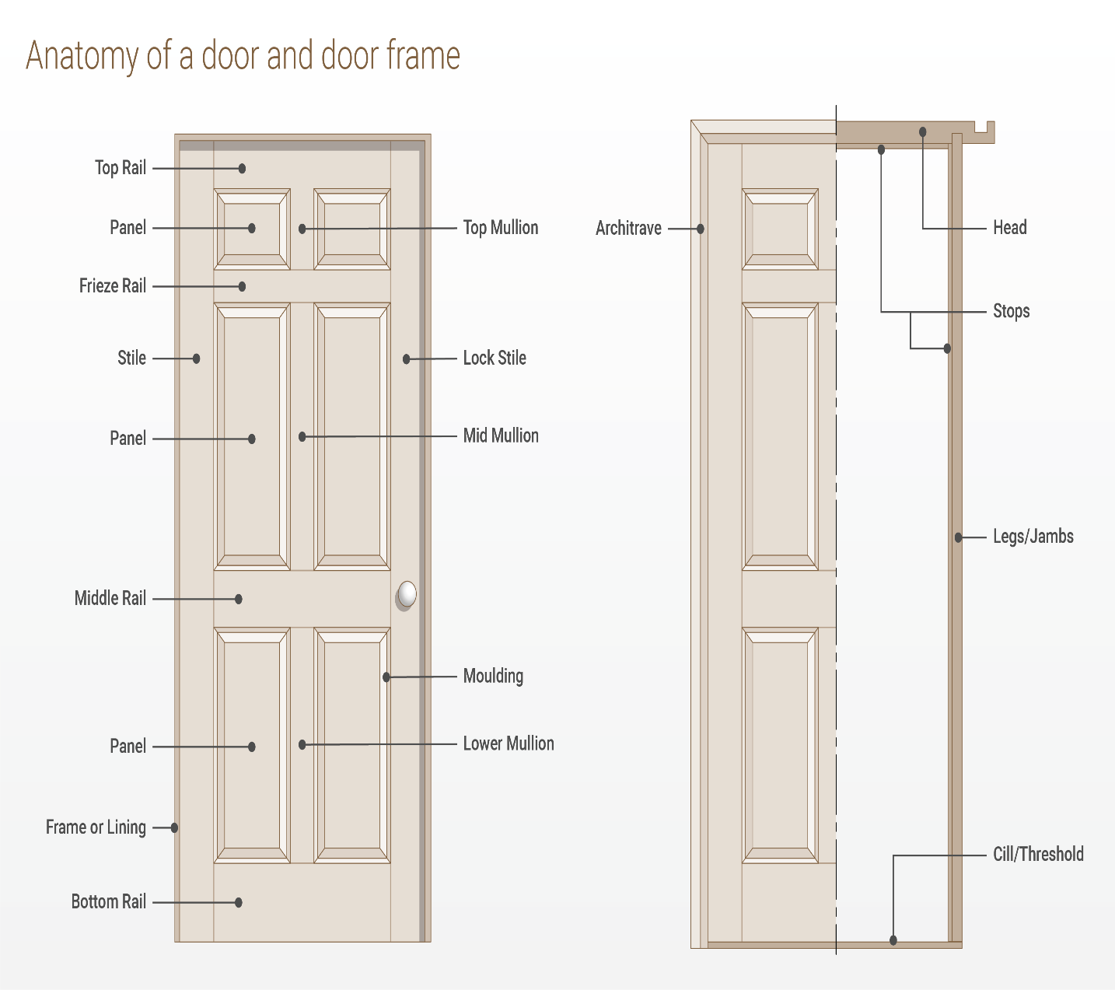

Parts of a door – glossary of terms
- Top rail – The top rail is the horizontal piece that sits across the very top of the door.
- Freeze rail - Similar to the top rail, except it sits horizontally across the next divide down between the panels on the door. This is often at eye height and not all doors have a cross rail. This is sometimes known as cross rail.
- Middle rail – Sits horizontally across the middle of the door. Not all doors have a middle rail.
- Bottom rail – Sits horizontally across the very bottom of the door.
- Stiles – This is the collective name for the vertical components that sit on the outside edge of a door.
- Lock stile – This is the vertical edge of the door which sits on the opposite side of the door to the hinges, and contains the lock or latch.
- Panel – The panels, which may be timber or glass, are what fill the frame formed by the stiles and rails of a door.
- Top mullion - This is the vertical element of the door that forms a division between different panels at the very top of a door. This is sometimes known as first mullion.
- Mid mullion - This is the vertical element that forms a division between panels in the area directly below the top mullion. This is sometimes known as second mullion.
- Lower mullion - This is the vertical element that forms a division between panels in the area directly below the mid mullion. This is sometimes known as third mullion.
- Moulding – This is decorative detailing that can be used around the edge of the door stiles, rails and mullions. It may be simple or highly decorative, such as crown moulding.
- Frame or lining – The door frame (external) or lining (internal) is what the door fits within and which covers the walls.

Parts of a door frame in detail
- Head – The head is the part of the door frame that sits horizontally to form the top of the frame.
- Legs/Jambs – These are the terms commonly used to refer to the vertical components that form the sides of the door frame.
- Stops – The stops are what the door rests against when closed, and are an integral part of the frame. In the case of door linings these are thin strips of wood that are mounted along the length of the jambs and head, to serve the same purpose.
- Architrave - This refers to the decorative moulding on the outer most edge of the door frame or lining.
- Cill or threshold – This is the bottom portion of an exterior door frame, and is used internally when transitioning from one floor covering to another.

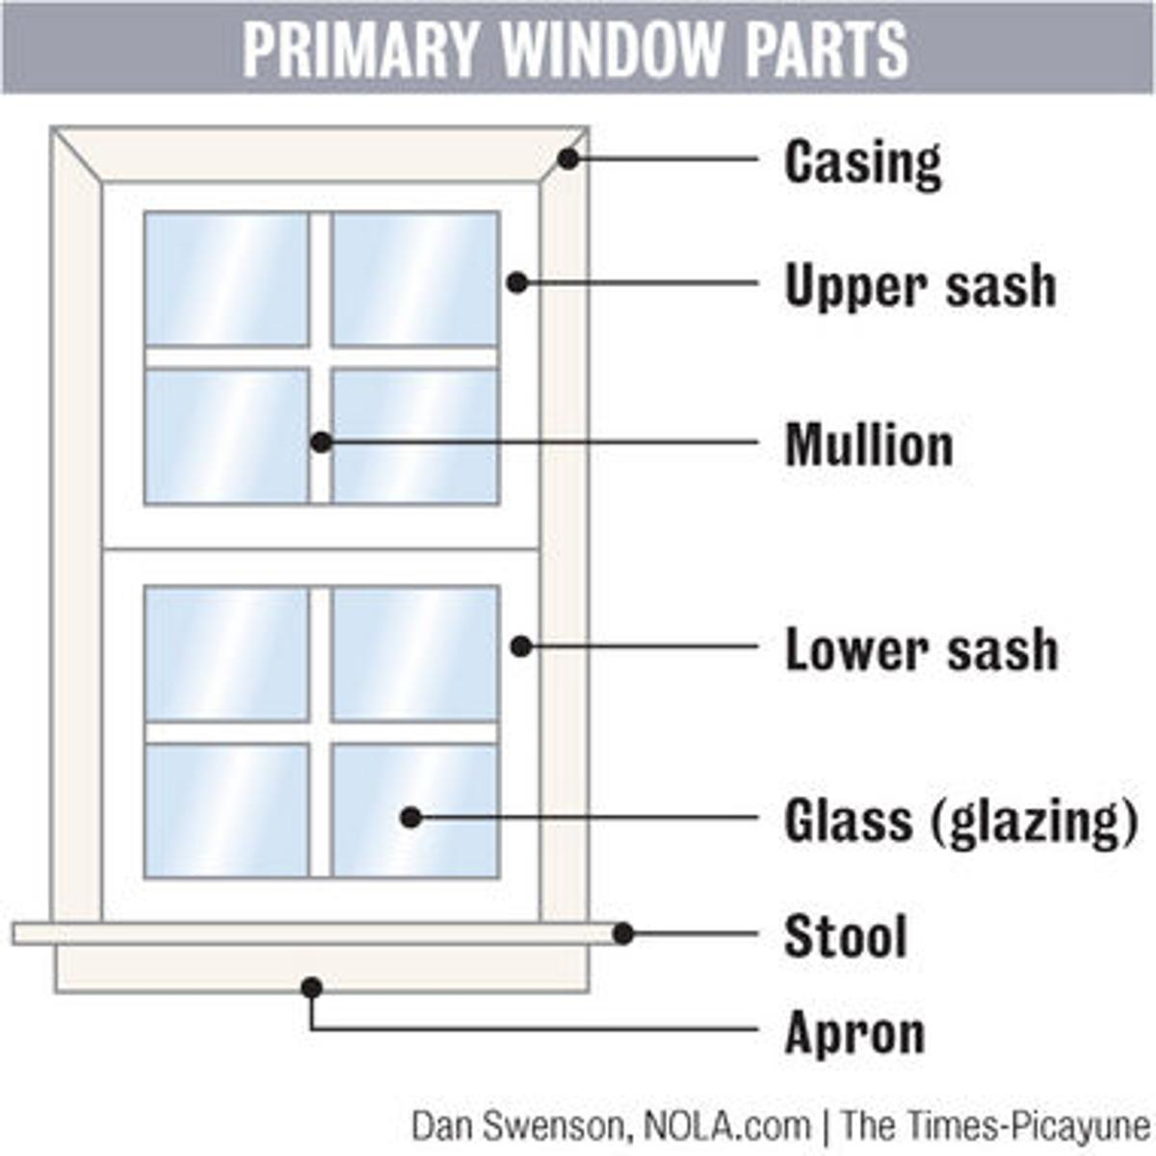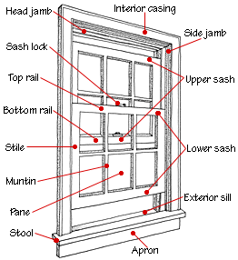

KEY FEATURES AND BENEFITS OF TIMBER WINDOWS AND DOORS

High thermal resistance

Timber has a high thermal resistance compared to other commonly used building products. This reduces heat losses and provides the following benefits: Warmer homes with lower energy bills.

No condensation on timber surfaces, providing a healthier indoor environment.

Long lifespan (Durability)

With proper maintenance the lifespan of windows and doors can extend to more than 100 years. Evidence of this can be seen in the many older colonial homes still using their original timber windows and doors and the benefit of this to a homeowner is cost savings over the extended life of a home.

More design flexibility

Timber windows and doors provide you with great design flexibility: As well as standard profiles you can also use customised window and door designs.

Lots of paint colours for the timber and many choices of hardware fittings are available to provide you with the finished look that you want.

You can change the look

If you choose high quality paint and hardware to go with your timber windows and doors you can expect them to remain in good condition for at least ten years. At the end of this time it is relatively easy to repaint the timber and replace the hardware. In doing so you can choose styles and colours to fit in with the latest trends.

Environmentally friendly

Timber is a renewable resource with a low carbon footprint. By choosing timber windows and doors you have the satisfaction of knowing you are helping to protect our environment for future generations of people to enjoy

Advantages of Timber Windows and Doors
Contrary to what you may think, most homeowners don't spend all this extra money on wooden windows just for their better looks. True, vinyl is the most common replacement window you will find today in any modern home. But does this mean that vinyl is a better material? Definitely not! There many people who will always go for the much more expensive option of getting quality wood frames. Despite certain drawbacks, wood has many advantages other than just good looks and is overall a much better material.
Purpose of this article is not to start a war on other materials used for windows but to present the pros and cons of wood, in an effort to help any potential buyer make a more informed decision

Aesthetics
As aforementioned, looks are one of the reasons many people choose wooden windows in the first place. For some, it's actually the only reason! After all, nothing can beat the elegant and warm looks of wood. Natural materials have a unique beauty and that’s why most window frames attempt to mimic the look of wood. There is no reason to settle for a cheap imitation if you can afford the real deal.
Furthermore, for certain old or more traditional homes, there really is no other aesthetically pleasing choice other than real wood windows. Simply put, genuine wood gives a look and a feel that nothing else can match.
Wood is also a winner in the looks department because it can accept all kinds of paints and colors the homeowner will choose to apply. No other material is as welcoming and accepting to paint as wood. Wood doesn't simply embrace paint, it needs it!

Insulation
You probably remember from school that wood is a bad conductor of heat. Obviously, this makes it a perfect choice for insulation. Quality wood frames are actually the best insulators available today. Wood provides 400 times more insulation than steel and 1,800 times more than aluminum-framed windows. In the long run, wood framed windows could save you from a lot of money since this additional insulation “bonus” will help keep your home warm in the winter and cool in the summer. Your bills will be greatly reduced, all year round.
Additionally, wood-framed windows are excellent at stopping outdoor sounds, being again much more effective than all other materials.
Timber is a brilliant alternative for great insulation. This superior insulation can also have a positive knock on effect on energy bills which of course, is never a bad thing!

Environmentally Sustainable
It might sound counter-intuitive to say it but timber as a product has a more positive environmental impact than almost any other material. Indeed, according to a recent report, timber products globally actually reduce the amount of CO2 in the atmosphere! So, when you install a set of timber windows and doors you can do so in the knowledge that you are doing your part for the environment.

Durability
Perhaps the most obvious advantage of timber is its durability and as a natural product it has existed and been used for construction within harsh environments for centuries. This makes it a very stable and reliable material for building works which includes windows and doors. This durability does come at a cost however, namely lots and lots of painting to ensure wood rot doesn’t set-in and reduce the overall life span of the timber.

Coefficient of Expansion
Wood has the smallest coefficient of expansion than other materials used in window production. This makes wooden windows stable and immobile and in turn allow you to select from a wide variety of designs

The Disadvantages of Wood Frames
These are the 5 main advantages of this great material. Nothing is perfect in this world and this is of course true for wooden windows.

1. The Need for Paint
Wood not only embraces paint, it actually needs it. And now you will learn why. Wood was once part of a living organism. If left untreated, it will eventually rot or start to look old.
Often, untreated window frames will swell from moisture, making it difficult (or impossible!) to raise or lower the window. This is especially true for houses near the sea. These homes generally require much more attention and care.

2. Insects
Insects are probably wood’s worst enemy, especially termites. However, painting your wooden frames protects both from humidity and insects.
Untreated wooden windows are proned to termites

3. Initial Cost Yes, wood windows have a much higher initial cost than any of the other materials used in window production. But as it was explained before, a quality and well maintained window will last much, much longer and will result in smaller utility bill each and every year. A really tight budget is the only excuse for not choosing wood.

Precautions While Installing Wooden Doors and Windows

The wooden doors and windows have two main parts one is a frame, and other is the shutter. Wooden doors and windows installation require proper selection with respect to the purpose of the use, workmanship in installation, and accessories fitting. Necessary precautions or guidelines should be exercised before wooden doors and windows installation because if not done properly then it will create many problems later.

Wooden Doors and Windows Installation
Complete the Following Points before Doors and Windows Installation:
01. Brick work should be completed first with required size of the opening before carrying out the doors and windows installation work.

02. The wood used for doors and windows frame and shutter should be free from blue stain, sapwood, decay, cracks, warping and dead knots.

03. The frame and shutter should be stocked in sufficient quantity to complete the doors and windows installation work.

04. Carpenter should have adequate tools and machinery for successful completion of the doors and windows installation work. Carpenter must have nail gun with nails, electric drill, jig saw, chainsaw, sander, jointer, planer, measure tape, plumb and marker.

Tools for Wooden Doors and Windows Installation
The size of the frame and shutter should be checked, and it should be accurate according to drawing or as per design and specification requirements before carry out the doors and windows installation work.

Checklist for Doors and Windows Installation:
(A) How to Install Doors and Windows Frame?
Checklist for the Doors and Windows Frame Installation.
01. Wooden doors and windows frame should be installed by grouting the holdfast with cement concrete.
The size of holdfast must be of adequate length and should be properly filled with cement concrete.

02. The fixing of the wooden frame should also be done parallel with brickwork.

03. The vertical member of the door frame should be checked for thickness and necessary allowance should be provided for cutting and smoothening of the frame member.

04. The bottom spacer and center spacer should be fixed, so that the frame member does not get bent and it should be grouted minimum 50 mm below finished floor level.

05. It is very important to decide facing of the frame as well as shutter groove of the frame with respect to the opening/closing direction of the shutter and for maximum movement of the shutter.

In the case of an outer main door, double grooves should be provided in the frame for the provision of grill door.

Once the frame is fixed in masonry or concrete, it is difficult to change the opening and closing direction of the shutter.

06. The surface of the frame coming in contact with brickwork or concrete needs to be well treated with the wood preservative like paint or tar coating before installing the frame.

07. The frame should be finished, and it should be smooth.
It should be erected in perfect plumb, line and level and diagonals to ensure smooth operation.

08. The frame joints should be checked, and it should be properly glued and secured with pins.

(B) How to Install Doors and Windows Shutter?
Checklist for the Doors and Windows Shutter Installation.

01. Provide a necessary allowance for cutting and smoothening of the shutter and some gap should also be provided for expansion of shutter due to moisture/ humidity.

02. The thickness of shutter should be minimum 40 mm for permanent use.

03. It is advisable, first to check the opening size of fixed frame and then decide the size of the shutter to reduce the errors and to achieve the good operation performance.

04. Provide minimum allowance (< 6 mm) between the frame and shutter to enhance the look of opening.

The gap between the shutter and finished floor should be minimum but remember that it should not scratch floor at the time of operations.

05. Shutter panel of ply should be waterproof and should be from the reputed company.

In the case of the glass panel, they should be checked, and they should be free from waves, bubble and other defects.

The Panel should be fixed in shutter without a gap, and the edges of the panel should be filled up with putty or beading.

06. The shutter should be installed with proper care. The screws should be of adequate size and should be tightened with the screwdriver only.

07. Finishing of shutter should be checked, and it should be smooth.

08. The shutter joints should be checked, and it should be properly glued and secured with bamboo pins.

09. The doors shutter shall have minimum three hinges and two fastenings like tower bolt, hasp and staple and locks.
The window shutter shall have a minimum two hinges and one fastening like tower bolt and one handle for opening and closing.
The size of hinges and fastening depend on the size of the shutter.

10. The surface of the shutter and frame needs to be well treated with the wood preservative like paint, varnish or polish after installing it. It is advisable that the polishing and waxing of shutter will enhance the life of shutter and also looks natural.
Work should be inspected for proper operation. They should operate smoothly and if shutter strike suddenly with frame then checks as there may a problem of verticality (Faulty Plumb).

Safety Precaution While Doors and Windows Installation:
01. Inspect ladder before climbing. It should not be a shaky ladder nor a ladder with slippery rugs.
02. Wear appropriate safety gear like safety helmet, facemask, hand gloves and safety shoe safety goggles at a time of installation.

03. First-Aid kit should be an easily available nearby place where installation work is being carried out.
04. Learn and use safe lifting technique to handle heavy materials.

